Answers to Selected Problems
of
Concepts of Programming Languages
Sixth Edition
R.W. Sebesta

Chapter 1
Problem Set:
3. Some arguments for having a single language for all programming domains are: It would dramatically cut the costs of programming training and compiler purchase and maintenance; it would simplify programmer recruiting and justify the development of numerous language dependent software development aids.
4. Some arguments against having a single language for all programming domains are: The language would necessarily be huge and complex; compilers would be expensive and costly to maintain; the language would probably not be very good for any programming domain, either in compiler efficiency or in the efficiency of the code it generated.
5. One possibility is wordiness. In some languages, a great deal of text is required for even simple complete programs. For example, COBOL is a very wordy language. In Ada, programs require a lot of duplication of declarations. Wordiness is usually considered a disadvantage, because it slows program creation, takes more file space for the source programs, and can cause programs to be more difficult to read.
7. The argument for using the right brace to close all compounds is simplicity—a right brace always terminates a compound. The argument against it is that when you see a right brace in a program, the location of its matching left brace is not always obvious, in part because all multiple-statement control constructs end with a right brace.
8. The reasons why a language would distinguish between uppercase and lowercase in its identifiers are: (1) So that variable identifiers may look different than identifiers that are names for constants, such as the convention of using uppercase for constant names and using lowercase for variable names in C, and (2) so that catenated words as names can have their first letter distinguished, as in TotalWords. (I think it is better to include a connector, such as underscore.) The primary reason why a language would not distinguish between uppercase and lowercase in identifiers is it makes programs less readable, because words that look very similar are actually completely different, such as SUM and Sum.
10. One of the main arguments is that regardless of the cost of hardware, it is not free. Why write a program that executes slower than is necessary. Furthermore, the difference between a well-written efficient program and one that is poorly written can be a factor of two or three. In many other fields of endeavor, the difference between a good job and a poor job may be 10 or 20 percent. In programming, the difference is much greater.
15. The use of type declaration statements for simple scalar variables may have very little effect on the readability of programs. If a language has no type declarations at all, it may be an aid to readability, because regardless of where a variable is seen in the program text, its type can be determined without looking elsewhere. Unfortunately, most languages that allow implicitly declared variables also include explicit declarations. In a program in such a language, the declaration of a variable must be found before the reader can determine the type of that variable when it is used in the program.
18. The main disadvantage of using paired delimiters for comments is that it results in diminished reliability. It is easy to inadvertently leave off the final delimiter, which extends the comment to the end of the next comment, effectively removing code from the program. The advantage of paired delimiters is that you can comment out areas of a program. The disadvantage of using only beginning delimiters is that they must be repeated on every line of a block of comments. This can be tedious and therefore error-prone. The advantage is that you cannot make the mistake of forgetting the closing delimiter.

Chapter 2
Problem Set:
6. Because of the simple syntax of LISP, few syntax errors occur in LISP programs. Unmatched parentheses is the most common mistake.
7. The main reason why imperative features were put in LISP was to increase its execution efficiency.
10. The main motivation for the development of PL/I was to provide a single tool for computer centers that must support both scientific and commercial applications. IBM believed that the needs of the two classes of applications were merging, at least to some degree. They felt that the simplest solution for a provider of systems, both hardware and software, was to furnish a single hardware system running a single programming language that served both scientific and commercial applications.
11. IBM was, for the most part, incorrect in its view of the future of the uses of computers, at least as far as languages are concerned. Commercial applications are nearly all done in languages that are specifically designed for them. Likewise for scientific applications. On the other hand, the IBM design of the 360 line of computers was a great success--it still dominates the area of computers between supercomputers and minicomputers. Furthermore, 360 series computers and their descendants have been widely used for both scientific and commercial applications. These applications have been done, in large part, in FORTRAN and COBOL.
14. The argument for typeless languages is their great flexibility for the programmer. Literally any storage location can be used to store any type value. This is useful for very low-level languages used for systems programming. The drawback is that type checking is impossible, so that it is entirely the programmer's responsibility to insure that expressions and assignments are correct.
18. A good deal of restraint must be used in revising programming languages. The greatest danger is that the revision process will continually add new features, so that the language grows more and more complex. Compounding the problem is the reluctance, because of existing software, to remove obsolete features.

Chapter 3
Instructor's Note:
In the program proof on page 149, there is a statement that may not be clear to all, specifically, (n + 1)* … * n = 1. The justification of this statement is as follows:
Consider the following expression:
(count + 1) * (count + 2) * … * n
The former expression states that when count is equal to n, the value of the later expression is 1. Multiply the later expression by the quotient:
(1 * 2 * … * count) / (1 * 2 * … * count)
whose value is 1, to get
(1 * 2 * … * count * (count + 1) * (count + 2) * … * n) /
(1 * 2 * … * count)
The numerator of this expressions is n!. The denominator is count!. If count is equal to n, the value of the quotient is
n! / n!
or 1, which is what we were trying to show.

Problem Set:
2a. <class_head> → {<modifier>} class <id> [extends class_name]
[implements <interface_name> {, <interface_name>}]
<modifier> → public | abstract | final
2c. <switch_stmt> → switch ( <expr> ) {case <literal> : <stmt_list>
{case <literal> : <stmt_list> } [default : <stmt_list>] }
3. <assign> → <id> = <expr>
<id> → A | B | C
<expr> → <expr> * <term>
| <term>
<term> → <factor> + <term>
| <factor>
<factor> → ( <expr> )
| <id>

6.
(a) <assign> => <id> = <expr>
=> A = <expr>
=> A = <id> * <expr>
=> A = A * <expr>
=> A = A * ( <expr> )
=> A = A * ( <id> + <expr> )
=> A = A * ( B + <expr> )
=> A = A * ( B + ( <expr> ) )
=> A = A * ( B + ( <id> * <expr> ) )
=> A = A * ( B + ( C * <expr> ) )
=> A = A * ( B + ( C * <id> ) )
=> A = A * ( B + ( C * A ) )

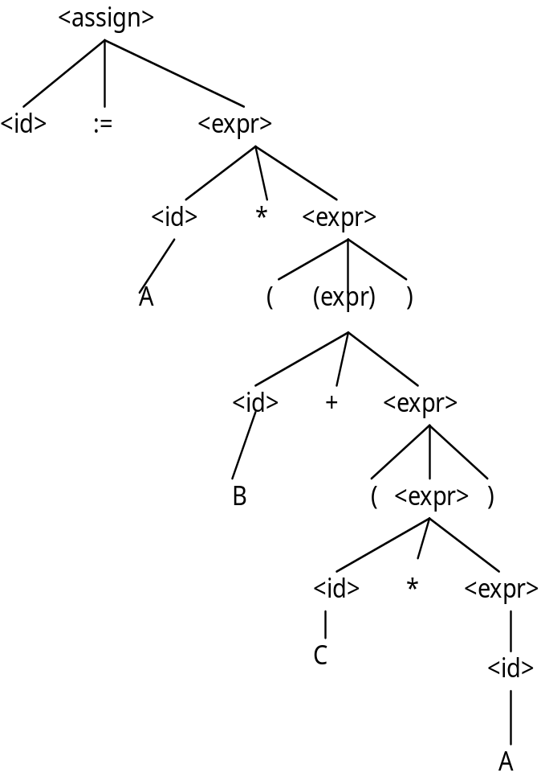

7.
(a) <assign> => <id> = <expr>
=> A = <expr>
=> A = <term>
=> A = <factor> * <term>
=> A = ( <expr> ) * <term>
=> A = ( <expr> + <term> ) * <term>
=> A = ( <term> + <term> ) * <term>
=> A = ( <factor> + <term> ) * <term>
=> A = ( <id> + <term> ) * <term>
=> A = ( A + <term> ) * <term>
=> A = ( A + <factor> ) * <term>
=> A = ( A + <id> ) * <term>
=> A = ( A + B ) * <term>
=> A = ( A + B ) * <factor>
=> A = ( A + B ) * <id>
=> A = ( A + B ) * C
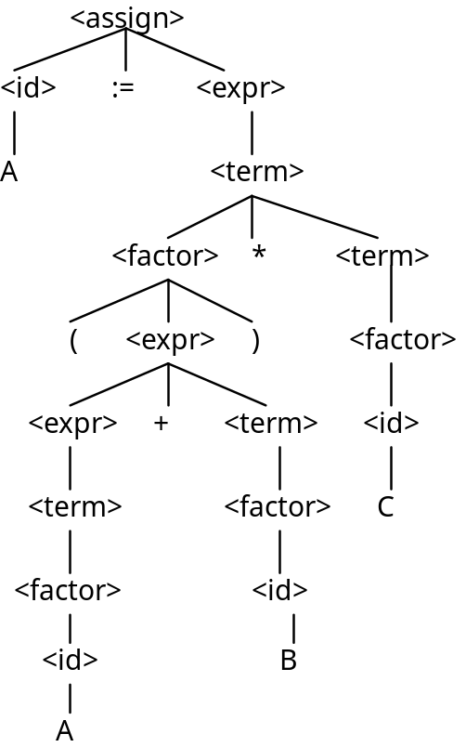
8. The following two distinct parse tree for the same string prove that the grammar is ambiguous.

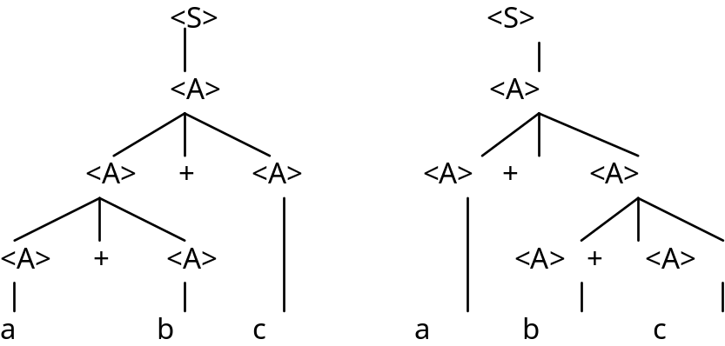

9. Assume that the unary operators can precede any operand. Replace the rule
<factor> → <id>
with
<factor> → + <id>
| - <id>

10. One or more a's followed by one or more b's followed by one or more c's.
13. S → a S b | a b
14.
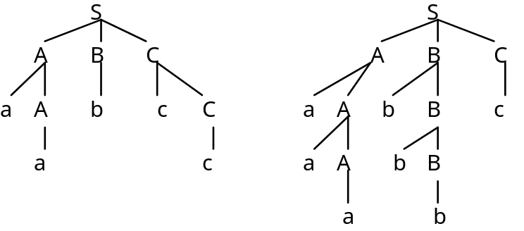
16. <assign> → <id> = <expr>
<id> → A | B | C
<expr> → <expr> (+ | -) <expr>
| (<expr>)
| <id>

18.
(a) (Pascal repeat) We assume that the logic expression is a single relational expression.
loop: ...
...
if <relational_expression> goto out
goto loop
out: ...

(b) (Ada for) for I in first .. last loop

I = first
loop: if I < last goto out
...
I = I + 1
goto loop
out: ...

(c) (Fortran Do)
K = start
loop: if K > end goto out
...
K = K + step
goto loop
out: ...

(e) (C for) for (expr1; expr2; expr3) ...
evaluate(expr1)
loop: control = evaluate(expr2)
if control == 0 goto out
...
evaluate(expr3)
goto loop
out: ...

19.
(a) a = 2 * (b - 1) - 1 {a > 0}
2 * (b - 1) - 1 > 0
2 * b - 2 - 1 > 0
2 * b > 3
b > 3 / 2

(b) b = (c + 10) / 3 {b > 6}
(c + 10) / 3 > 6
c + 10 > 18
c > 8

(c) a = a + 2 * b - 1 {a > 1}
a + 2 * b - 1 > 1
2 * b > 2 - a
b > 1 - a / 2

(d) x = 2 * y + x - 1 {x > 11}
2 * y + x - 1 > 11
2 * y + x > 12

20.
(a) a = 2 * b + 1
b = a - 3 {b < 0}

a - 3 < 0
a < 3

Now, we have:
a = 2 * b + 1 {a < 3}
2 * b + 1 < 3
2 * b + 1 < 3
2 * b < 2
b < 1

(b) a = 3 * (2 * b + a);
b = 2 * a - 1 {b > 5}
2 * a - 1 > 5
2 * a > 6
a > 3
Now we have:
a = 3 * (2 * b + a) {a > 3}
3 * (2 * b + a) > 3
6 * b + 3 * a > 3
2 * b + a > 1
n > (1 - a) / 2

21a. Mpf(for var in init_expr .. final_expr loop L end loop, s)
if VARMAP(i, s) = undef for var or some i in init_expr or final_expr
then error
else if Me(init_expr, s) > Me(final_expr, s)
then s
else Ml(while init_expr - 1 <= final_expr do L, Ma(var := init_expr + 1, s))

21b. Mr(repeat L until B)
if Mb(B, s) = undef
then error
else if Msl(L, s) = error
then error
else if Mb(B, s) = true
then Msl(L, s)
else Mr(repeat L until B), Msl(L, s))

21c. Mb(B, s) if VARMAP(i, s) = undef for some i in B
then error
else B', where B' is the result of
evaluating B after setting each
variable i in B to VARMAP(i, s)

21d. M_{cf}(for (expr1; expr2; expr3) L, s)
if VARMAP (i, s) = undef for some i in expr1, expr2, expr3, or L
then error
else if M_{e} (expr2, M_{e} (expr1, s)) = 0
then s
else M_{help} (expr2, expr3, L, s)
M_{help} (expr2, expr3, L, s)
if VARMAP (i, s) = undef for some i in expr2, expr3, or L
then error
else
if M_{sl} (L, s) = error
then s
else M_{help} (expr2, expr3, L, M_{sl} (L, M_{e} (expr3, s))

22. The value of an intrisic attribute is supplied from outside the attribute evaluation process, usually from the lexical analyzer. A value of a synthesized attribute is computed by an attribute evaluation function.

23. Replace the second semantic rule with:
<var>[2].env ← <expr>.env
<var>[3].env ← <expr>.env
<expr>.actual_type ← <var>[2].actual_type
predicate: <var>[2].actual_type = <var>[3].actual_type
Chapter 4
Problem Set:
1.
(a) FIRST(aB) = {a}, FIRST(b) = {b}, FIRST(cBB) = {c}, Passes the test
(b) FIRST(aB) = {a}, FIRST(bA) = {b}, FIRST(aBb) = {a}, Fails the test
(c) FIRST(aaA) = {a}, FIRST(b) = {b}, FIRST(caB) = {c}, Passes the test

3.
(a) aaAbb
S

a A b

a A B

b
Phrases: aaAbb, aAb, b
Simple phrases: b
Handle: b

(b) bBab S

b B A

a b
Phrases: bBab, ab
Simple phrases: ab
Handle: ab
5. Stack Input Action
0 id * (id + id) $ Shift 5
0id5 * (id + id) $ Reduce 6 (Use GOTO[0, F])
0F3 * (id + id) $ Reduce 4 (Use GOTO[0, T])
0T2 * (id + id) $ Reduce 2 (Use GOTO[0, E])
0T2*7 (id + id) $ Shift 7
0T2*7(4 id + id ) $ Shift 4
0T2*7(4id5 + id ) $ Shift 5
0T2*7(4F3 + id ) $ Reduce 6 (Use GOTO[4, F])
0T2*7(4T2 + id ) $ Reduce 4 (Use GOTO[4, T])
0T2*7(4E8 + id ) $ Reduce 2 (Use GOTO[4, E])
0T2*7(4E8+6 id ) $ Shift 6
0T2*7(4E8+6id5 ) $ Shift 5
0T2*7(4E8+6F3 ) $ Reduce 6 (Use GOTO[6, F])
0T2*7(4E8+6T9 ) $ Reduce 4 (Use GOTO[6, T])
0T2*7(4E8 ) $ Reduce 1 (Use GOTO[4, E])
0T2*7(4E8)11 $ Shift 11
0T2*7F10 $ Reduce 5 (Use GOTO[7, F])
0T2 $ Reduce 5 (Use GOTO[0, T])
0E1 $ Reduce 2 (Use GOTO[0, E])
--ACCEPT--

Programming Exercises:
1. Every arc in this graph is assumed to have addChar attached. Assume we get here only if charClass is SLASH.
other
/ * * /
start slash com end return COMMENT
other
return SLASH_CODE

3. int getComment() {
getChar();
/* The slash state */
if (charClass != AST)
return SLASH_CODE;
else {
/* The com state-end state loop */
do {
getChar();
/* The com state loop */
while (charClass != AST)
getChar();
} while (charClass != SLASH);
return COMMENT;
}

Chapter 5
Problem Set:
2. The advantage of a typeless language is flexibility; any variable can be used for any type values. The disadvantage is poor reliability due to the ease with which type errors can be made, coupled with the impossibility of type checking detecting them.
3. This is a good idea. It adds immensely to the readability of programs. Furthermore, aliasing can be minimized by enforcing programming standards that disallow access to the array in any executable statements. The alternative to this aliasing would be to pass many parameters, which is a highly inefficient process.
5. Implicit heap-dynamic variables acquire types only when assigned values, which must be at runtime. Therefore, these variables are always dynamically bound to types.
6. Suppose that a Fortran subroutine is used to implement a data structure as an abstraction. In this situation, it is essential that the structure persist between calls to the managing subroutine.

8.
(a) i. Sub1
ii. Sub1
iii. Main
(b) i. Sub1
ii. Sub1
iii. Sub1

9. Static scoping: x = 5.
Dynamic scoping: x = 10

10. Variable Where Declared
In Sub1:
A Sub1
Y Sub1
Z Sub1
X Main
In Sub2:
A Sub2
B Sub2
Z Sub2
Y Sub1
X Main
In Sub3:
A Sub3
X Sub3
W Sub3
Y Main
Z Main

12. Point 1: a 1
b 2
c 2
d 2
Point 2: a 1
b 2
c 3
d 3
e 3
Point 3: same as Point 1
Point 4: a 1
b 1
c 1
13. Variable Where Declared
(a) d, e, f fun3
c fun2
b fun1
a main
(b) d, e, f fun3
b, c fun1
a main
(c) b, c, d fun1
e, f fun3
a main
(d) b, c, d fun1
e, f fun3
a main
(e) c, d, e fun2
f fun3
b fun1
a main
(f) b, c, d fun1
e fun2
f fun3
a main

14. Variable Where Declared
(a) A, X, W Sub3
B, Z Sub2
Y Sub1
(b) A, X, W Sub3
Y, Z Sub1
(c) A, Y, Z Sub1
X, W Sub3
B Sub2
(d) A, Y, Z Sub1
X, W Sub3
(e) A, B, Z Sub2
X, W Sub3
Y Sub1
(f) A, Y, Z Sub1
B Sub2
X, W Sub3

Chapter 6
Problem Set:
1. Boolean variables stored as single bits are very space efficient, but on most computers access to them is slower than if they were stored as bytes.
2. Integer values stored in decimal waste storage in binary memory computers, simply as a result of the fact that it takes four binary bits to store a single decimal digit, but those four bits are capable of storing 16 different values. Therefore, the ability to store six out of every 16 possible values is wasted. Numeric values can be stored efficiently on binary memory computers only in number bases that are multiples of 2. If humans had developed a number of fingers that was a power of 2, these kinds of problems would not occur.
6. When implicit dereferencing of pointers occurs only in certain contexts, it makes the language slightly less orthogonal. The context of the reference to the pointer determines its meaning. This detracts from the readability of the language and makes it slightly more difficult to learn.
7. The only justification for the -> operator in C and C++ is writability. It is slightly easier to write p -> q than (*p).q.
8. The advantage of having a separate construct for unions is that it clearly shows that unions are different from records. The disadvantages are that it requires an additional reserved word and that unions are often separately defined but included in records, thereby complicating the program that uses them.
9. Let the subscript ranges of the three dimensions be named min(1), min(2), min(3), max(1), max(2), and max(3). Let the sizes of the subscript ranges be size(1), size(2), and size(3). Assume the element size is 1.
Row Major Order:
location(a[i,j,k]) = (address of a[min(1),min(2),min(3)])
+((i-min(1))*size(3) + (j-min(2)))*size(2) + (k-min(3))
Column Major Order:
location(a[i,j,k]) = (address of a[min(1),min(2),min(3)])
+((k-min(3))*size(1) + (j-min(2)))*size(2) + (i-min(1))
10. The advantage of this scheme is that accesses that are done in order of the rows can be made very fast; once the pointer to a row is gotten, all of the elements of the row can be fetched very quickly. If, however, the elements of a matrix must be accessed in column order, these accesses will be much slower; every access requires the fetch of a row pointer and an address computation from there. Note that this access technique was devised to allow multidimensional array rows to be segments in a virtual storage management technique. Using this method, multidimensional arrays could be stored and manipulated that are much larger than the physical memory of the computer.

14. Implicit heap storage recovery eliminates the creation of dangling pointers through explicit deallocation operations, such as delete. The disadvantage of implicit heap storage recovery is the execution time cost of doing the recovery, often when it is not even necessary (there is no shortage of heap storage).

Chapter 7
Problem Set:
1. Suppose Type1 is a subrange of Integer. It may be useful for the difference between Type1 and Integer to be ignored by the compiler in an expression.
7. An expression such as a + fun(b), as described on page 300.
8. Consider the integer expression A + B + C. Suppose the values of A, B, and C are 20,000, 25,000, and -20,000, respectively. Further suppose that the machine has a maximum integer value of 32,767. If the first addition is computed first, it will result in overflow. If the second addition is done first, the whole expression can be correctly computed.
9.
(a) ( ( ( a * b )1 - 1 )2 + c )3
(b) ( ( ( a * ( b - 1 )1 )2 / c )3 mod d )4
(c) ( ( ( a - b )1 / c )2 & ( ( ( d * e )3 / a )4 - 3 )5 )6
(d) ( ( ( - a )1 or ( c = d )2 )3 and e )4
(e) ( ( a > b )1 xor ( c or ( d <= 17 )2 )3 )4
(f) ( - ( a + b )1 )2

10.
(a) ( a * ( b - ( 1 + c )1 )2 )3
(b) ( a * ( ( b - 1 )2 / ( c mod d )1 )3 )4
(c) ( ( a - b )5 / ( c & ( d * ( e / ( a - 3 )1 )2 )3 )4 )6
(d) ( - ( a or ( c = ( d and e )1 )2 )3 )4
(e) ( a > ( xor ( c or ( d <= 17 )1 )2 )3 )4
(f) ( - ( a + b )1 )2

11. <expr> → <expr> or <e1> | <expr> xor <e1> | <e1>
<e1> → <e1> and <e2> | <e2>
<e2> → <e2> = <e3> | <e2> /= <e3> | <e2> < <e3>
| <e2> <= <e3> | <e2> > <e3> | <e2> >= <e3> | <e3>
<e3> → <e4>
<e4> → <e4> + <e5> | <e4> - <e5> | <e4> & <e5> | <e4> mod <e5> | <e5>
<e5> → <e5> * <e6> | <e5> / <e6> | not <e5> | <e6>
<e6> → a | b | c | d | e | const | ( <expr> )
12. (a)
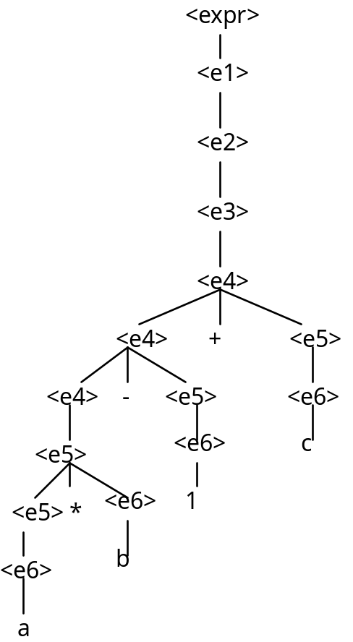
12. (b)
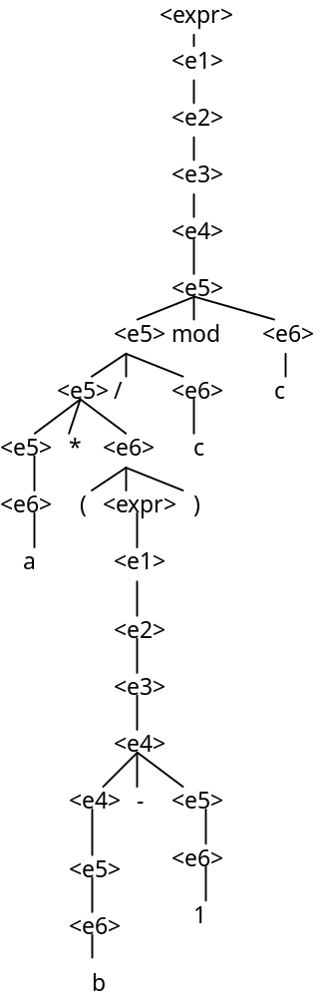
12. (c)
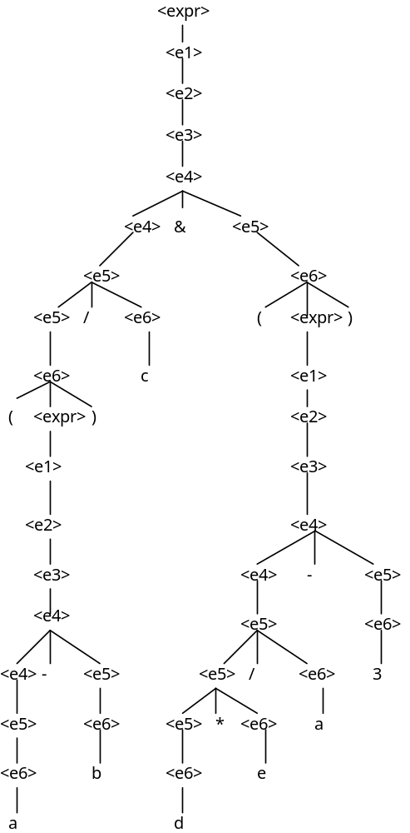
12. (d)
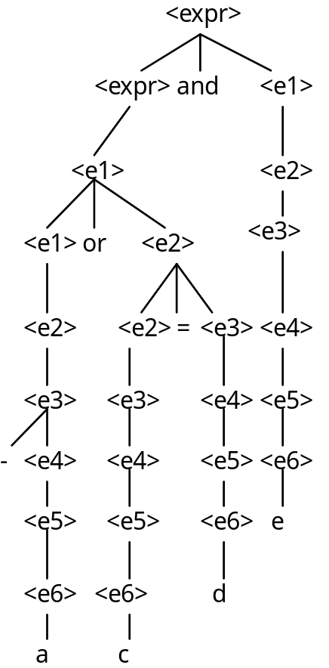
12. (e)
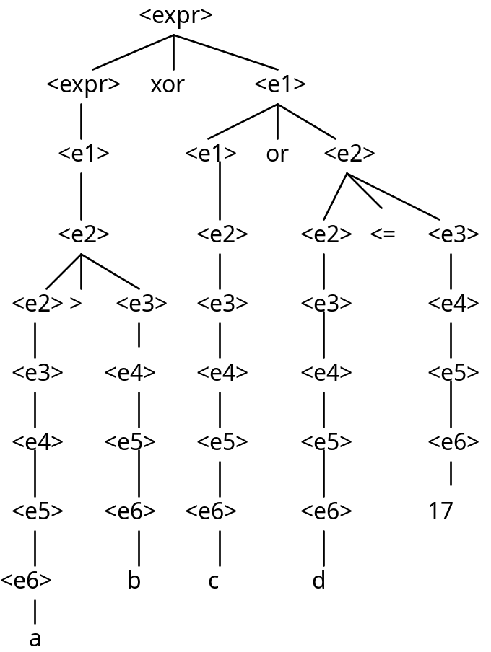
12. (f)
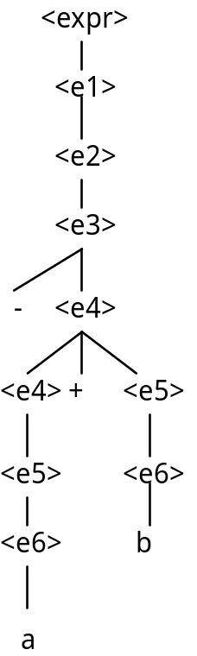

13. (a) (left -> right) sum1 is 46; sum2 is 48
(b) (right -> left) sum1 is 48; sum2 is 46

Chapter 8
Problem Set:
1. Three situations in which a combined counting and logical control loops are:
a. A list of values is to be added to a SUM, but the loop is to be exited if SUM exceeds some prescribed value.
b. A list of values is to be read into an array, where the reading is to terminate when either a prescribed number of values have been read or some special value is found in the list.
c. The values stored in a linked list are to be moved to an array, where values are to be moved until the end of the linked list is found or the array is filled, whichever comes first.
4. Unique closing keywords on compound statements have the advantage of readability and the disadvantage of complicating the language by increasing the number of keywords.
8. The primary argument for using Boolean expressions exclusively as control expressions is the reliability that results from disallowing a wide range of types for this use. In C, for example, an expression of any type can appear as a control expression, so typing errors that result in references to variables of incorrect types are not detected by the compiler as errors.

Programming Exercises:
1.
(a) Do K = (J + 13) / 27, 10
I = 3 * (K + 1) - 1
End Do
(b) for k in (j + 13) / 27 .. 10 loop
i := 3 * (k + 1) - 1;
end loop;
(c) for (k = (j + 13) / 27; k <= 10; i = 3 * (++k) - 1)

2.
(a) Do K = (J + 13.0) / 27.0, 10.0, 1.2
I = 3.0 * (K + 1.2) - 1.0
End Do
(b) while (k <= 10.0) loop
i := 3.0 * (k + 1.2) - 1.0;
k := k + 1.2;
end loop;
(c ) for (k = (j + 13.0) / 27.0; k <= 10.0;
k = k + 1.2, i = 3.0 * k - 1)
3.
(a) Select Case (k)
Case (1, 2)
J = 2 * K - 1
Case (3, 5)
J = 3 * K + 1
Case (4)
J = 4 * K - 1
Case (6, 7, 8)
J = K - 2
Case Default
Print *, 'Error in Select, K = ', K
End Select
(b) case k is
when 1 | 2 => j := 2 * k - 1;
when 3 | 5 => j := 3 * k + 1;
when 4 => j := 4 * k - 1;
when 6..8 => j := k - 2;
when others =>
Put ("Error in case, k =');
Put (k);
New_Line;
end case;
(c) switch (k)
{
case 1: case 2:
j = 2 * k - 1;
break;
case 3: case 5:
j = 3 * k + 1;
break;
case 4:
j = 4 * k - 1;
break;
case 6: case 7: case 8:
j = k - 2;
break;
default:
printf("Error in switch, k =%d\n", k);
}
4. j = -3;
key = j + 2;
for (i = 0; i < 10; i++){
if ((key == 3) || (key == 2))
j--;
else if (key == 0)
j += 2;
else j = 0;
if (j > 0)
break;
else j = 3 - i;
}
5. (C)
for (i = 1; i <= n; i++) {
flag = 1;
for (j = 1; j <= n; j++)
if (x[i][j] <> 0) {
flag = 0;
break;
}
if (flag == 1) {
printf("First all-zero row is: %d\n", i);
break;
}
}

(Ada)
for I in 1..N loop
Flag := true;
for J in 1..N loop
if X(I, J) /= 0 then
Flag := false;
exit;
end if;
end loop;
if Flag = true then
Put("First all-zero row is: ");
Put(I);
Skip_Line;
exit;
end if;
end loop;

Chapter 9
Problem Set:
2. The main advantage of this method is the fast accesses to formal parameters in subprograms. The disadvantages are that recursion is rarely useful when values cannot be passed, and also that a number of problems, such as aliasing, occur with the method.
4. This can be done in both Java and C#, using a static (or class) data member for the page number.
5. Assume the calls are not accumulative; that is, they are always called with the initialized values of the variables, so their effects are not accumulative.
a. 2, 1, 3, 5, 7, 9 b. 1, 2, 3, 5, 7, 9 c. 1, 2, 3, 5, 7, 9
2, 1, 3, 5, 7, 9 2, 3, 1, 5, 7, 9 2, 3, 1, 5, 7, 9
2, 1, 3, 5, 7, 9 5, 1, 3, 2, 7, 9 5, 1, 3, 2, 7, 9 (unless the addresses of the
actual parameters are
recomputed on return, in
which case there will be an
index range error.)

6. It is rather weak, but one could argue that having both adds complexity to the language without sufficient increase in writability.
Chapter 10
Problem Set:
1.
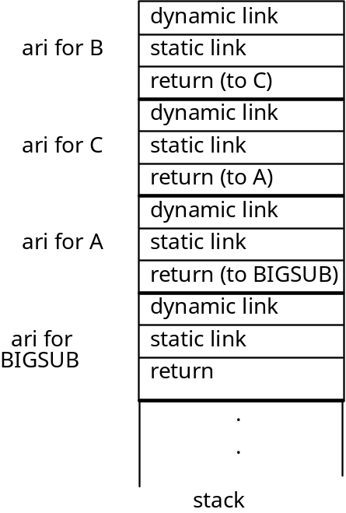
2.
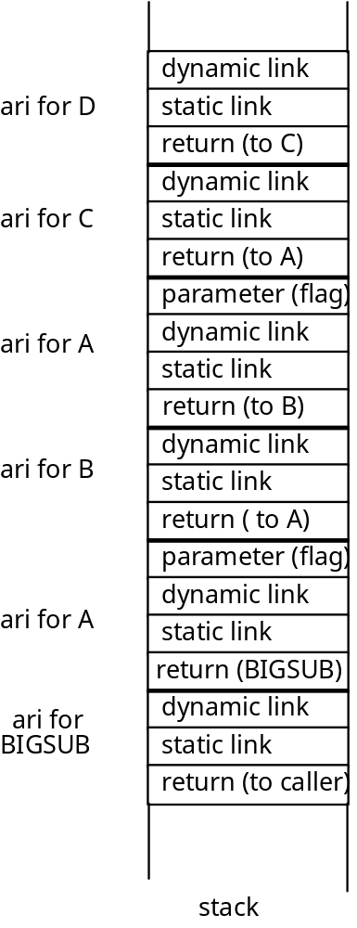
4. One very simple alternative is to assign integer values to all variable names used in the program. Then the integer values could be used in the activation records, and the comparisons would be between integer values, which are much faster than string comparisons.
5. Following the hint stated with the question, the target of every goto in a program could be represented as an address and a nesting_depth, where the nesting_depth is the difference between the nesting level of the procedure that contains the goto and that of the procedure containing the target. Then, when a goto is executed, the static chain is followed by the number of links indicated in the nesting_depth of the goto target. The stack top pointer is reset to the top of the activation record at the end of the chain.
6. Including two static links would reduce the access time to nonlocals that are defined in scopes two steps away to be equal to that for nonlocals that are one step away. Overall, because most nonlocal references are relatively close, this could significantly increase the execution efficiency of many programs.

Chapter 11
Problem Set:
2. The problem with this is that the user is given access to the stack through the returned value of the "top" function. For example, if p is a pointer to objects of the type stored in the stack, we could have:
p = top(stack1);
*p = 42;
These statements access the stack directly, which violates the principle of a data abstraction.

Chapter 12
Problem Set:
1. In C++, a method can only be dynamically bound if all of its ancestors are marked virtual. Be default, all method binding is static. In Java, method binding is dynamic by default. Static binding only occurs if the method is marked final, which means it cannot be overriden.
3. C++ has extensive access controls to its class entities. Individual entities can be marked public, private, or protected, and the derivation process itself can impose further access controls by being private. Ada, on the other hand, has no way to restrict inheritance of entities (other than through child libraries, which this book does not describe), and no access controls for the derivation process.

Chapter 13
Problem Set:
1. Competition synchronization is not necessary when no actual concurrency takes place simply because there can be no concurrent contention for shared resources. Two nonconcurrent processes cannot arrive at a resource at the same time.
2. When deadlock occurs, assuming that only two program units are causing the deadlock, one of the involved program units should be gracefully terminated, thereby allowed the other to continue.
3. The main problem with busy waiting is that machine cycles are wasted in the process.
4. Deadlock would occur if the release(access) were replaced by a wait(access) in the consumer process, because instead of relinquishing access control, the consumer would wait for control that it already had.
6. Sequence 1: A fetches the value of BUF_SIZE (6)
A adds 2 to the value (8)
A puts 8 in BUF_SIZE
B fetches the value of BUF_SIZE (8)
B subtracts 1 (7)
B put 7 in BUF_SIZE
BUF_SIZE = 7
Sequence 2: A fetches the value of BUF_SIZE (6)
B fetches the value of BUF_SIZE (6)
A adds 2 (8)
B subtracts 1 (5)
A puts 8 in BUF_SIZE
B puts 5 in BUF_SIZE
BUF_SIZE = 5
Sequence 3: A fetches the value of BUF_SIZE (6)
B fetches the value of BUF_SIZE (6)
A adds 2 (8)
B subtracts 1 (5)
B puts 5 in BUF_SIZE
A puts 8 in BUF_SIZE
BUF_SIZE = 8

Many other sequences are possible, but all produce the values 5, 7, or 8.

Chapter 14
Problem Set:
5. There are several advantages of a linguistic mechanism for handling exceptions, such as that found in Ada, over simply using a flag error parameter in all subprograms. One advantage is that the code to test the flag after every call is eliminated. Such testing makes programs longer and harder to read. Another advantage is that exceptions can be propagated farther than one level of control in a uniform and implicit way. Finally, there is the advantage that all programs use a uniform method for dealing with unusual circumstances, leading to enhanced readability.
6. There are several disadvantages of sending error handling subprograms to other subprograms. One is that it may be necessary to send several error handlers to some subprograms, greatly complicating both the writing and execution of calls. Another is that there is no method of propagating exceptions, meaning that they must all be handled locally. This complicates exception handling, because it requires more attention to handling in more places.

Chapter 15
Problem Set :
6. y returns the given list with leading elements removed up to but not including the first occurrence of the first given parameter.
7. x returns the number of non-NIL atoms in the given list.

Programming Exercises:
5. (DEFINE (deleteall atm lst)
(COND
((NULL? lst) '())
((EQ? atm (CAR lst)) (deleteall atm (CDR lst)))
(ELSE (CONS (CAR lst) (deleteall atm (CDR lst)))
))
7. (DEFINE (deleteall atm lst)
(COND
((NULL? lst) '())
((NOT (LIST? (CAR lst)))
(COND
((EQ? atm (CAR lst)) (deleteall atm (CDR lst)))
(ELSE (CONS (CAR lst) (deleteall atm (CDR lst))))
))
(ELSE (CONS (deleteall atm (CAR lst))
(deleteall atm (CDR lst))))
))
9. (DEFINE (reverse lis)
(COND
((NULL? lis) '())
(ELSE (APPEND (reverse (CDR lis)) (CONS (CAR lis) () )))
))

Chapter 16
Problem Set:
1. Ada variables are statically bound to types. Prolog variables are bound to types only when they are bound to values. These bindings take place during execution and are tempoarary.
2. On a single processor machine, the resolution process takes place on the rule base, one rule at a time, starting with the first rule, and progressing toward the last until a match is found. Because the process on each rule is independent of the process on the other rules, separate processors could concurrently operate on separate rules. When any of the processors finds a match, all resolution processing could terminate.
6. The list processing capabilities of Scheme and Prolog are similar in that they both treat lists as consisting of two parts, head and tail, and in that they use recursion to traverse and process lists.
7. The list processing capabilities of Scheme and Prolog are different in that Scheme relies on the primitive functions CAR, CDR, and CONS to build and dismantle lists, whereas with Prolog these functions are not necessary.

Programming Exercises:
2. intersect([], X, []).
intersect([X | R], Y, [X | Z] :-
member(X, Y),
!,
intersect(R, Y, Z).
intersect([X | R], Y, Z) :- intersect(R, Y, Z).
Note: this code assumes that the two lists, X and Y, contain no duplicate elements.

3. union([], X, X).
union([X | R], Y, Z) :- member(X, Y), !, union(R, Y, Z).
union([X | R], Y, [X | Z]) :- union(R, Y, Z).

